Web Dev Assignment outline

Driving school web application.
- Register: create, read, update, and delete a profile with personal information.
- Log in and log out with authentication.
- Browse driving instructors, description, and their car.
- Review section for the school or instructors.
- Ability to make a booking for lessons.
- Can search for available instructors and their location using map.
- Filter by location, gender, availability etc.
- Account section to manage active bookings and progress tracking.

Pages needed:
- Home page. -Gav
- Brief overview
- Carousel of the instructor and their car brings them to instructor details.
- Contact us.
- The menu that links to all the pages at the top
- Bootstrap (mobile oriented)

- Log in / register. -Owen
- Search/map page, search the areas and times.
- Account management. -Owen
- Reviews. -Gav
- Instructor’s details. - Gav
- Frequently asked questions. -Gav
- Page for booking time slots. - Owen

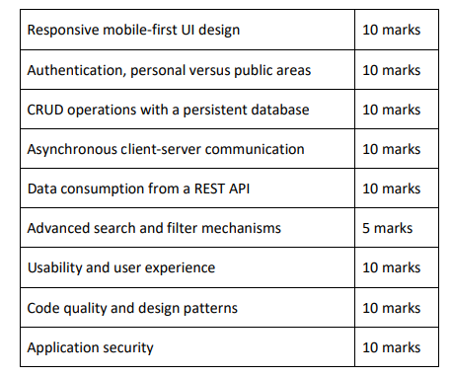

Pages:

